ASDV
Machine Problem Multidimensional Arrays

Problem 2D
Write the following function that tests whether a two-dimensional list has four consecutive numbers of the same value, either horizontally, vertically, or diagonally.

public static boolean isConsecutiveFour(int[][] values)

Write a test program that prompts the user to enter the number of rows and columns of a two-dimensional list and then the values in the list and displays True if the list contains four consecutive numbers with the same value. Otherwise, display False. Here are some examples of the true cases:
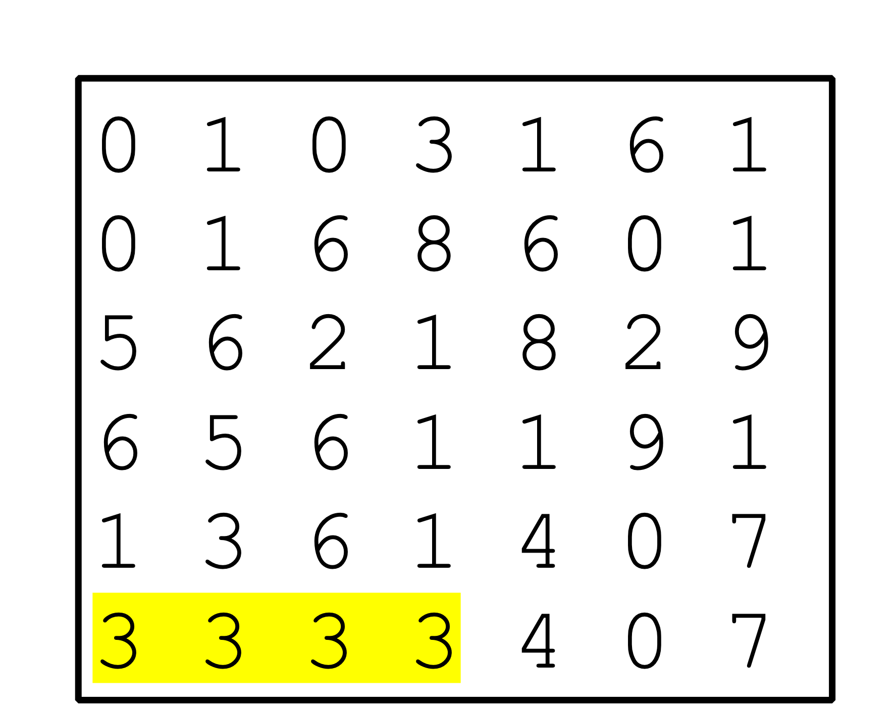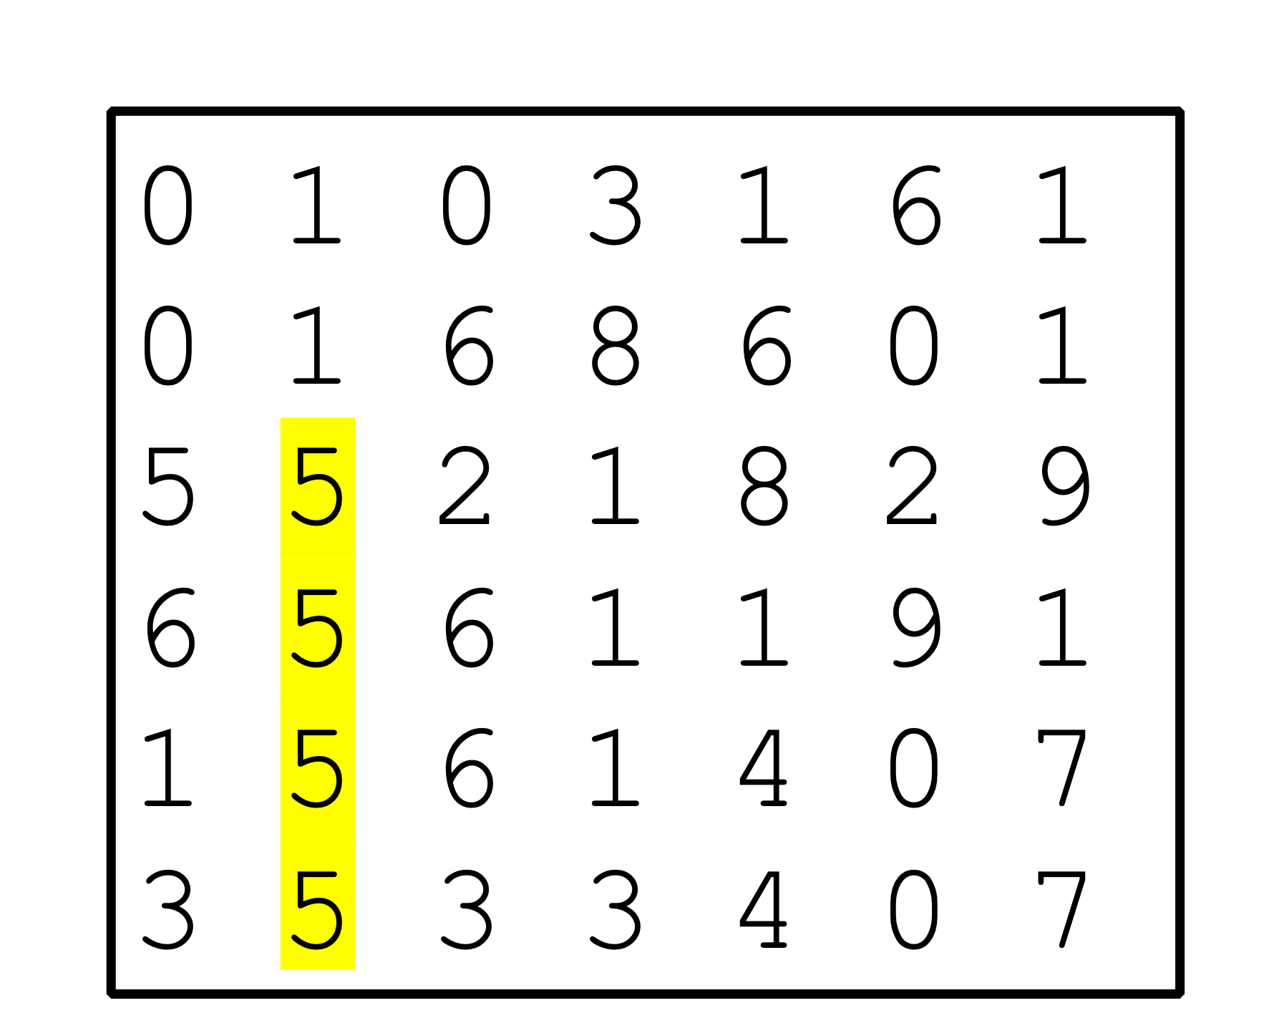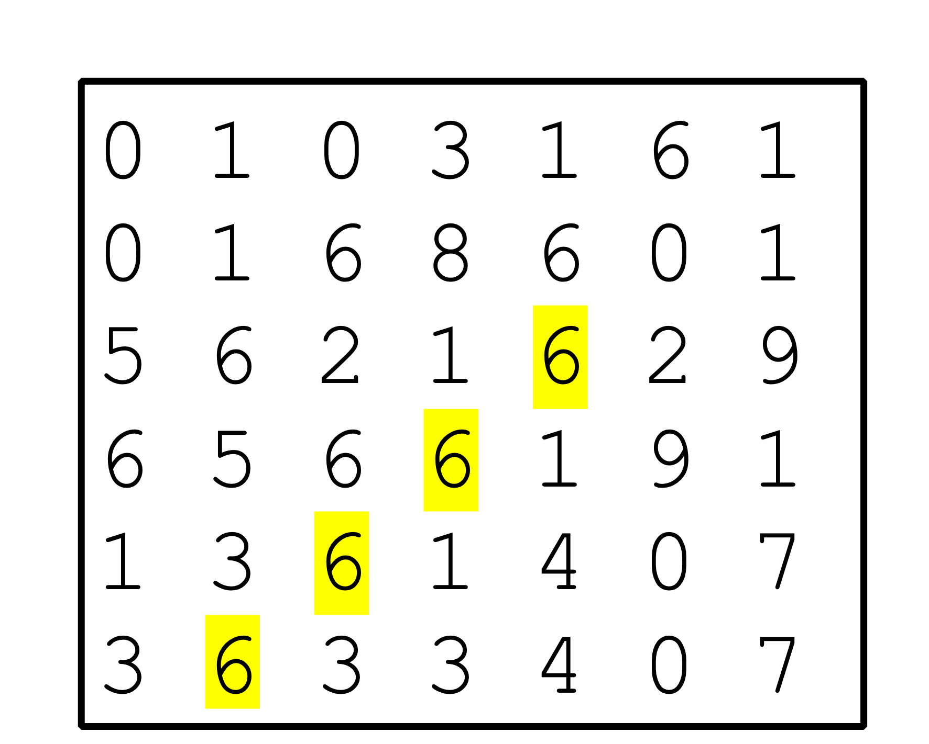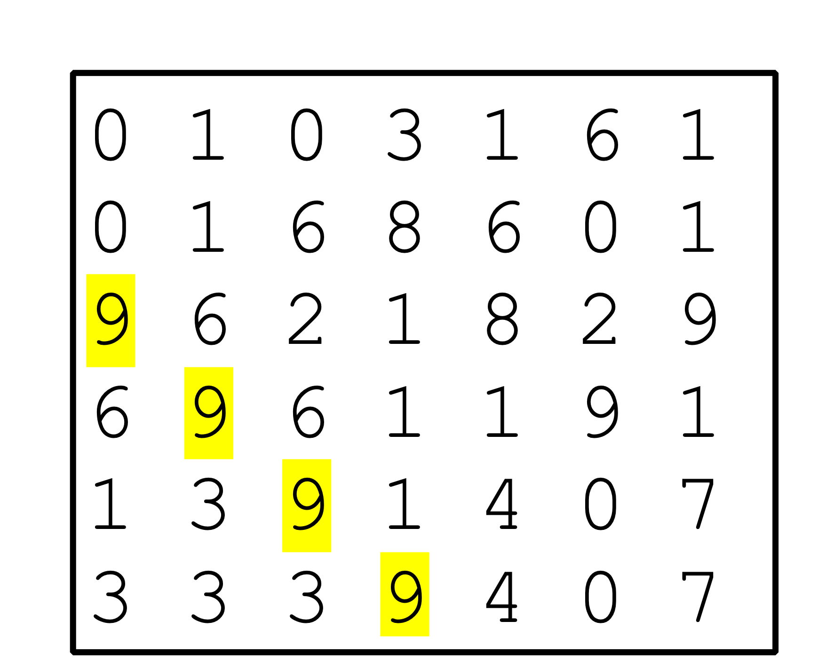

Problem 3D
Implement the following methods sorts a collection of tables of names.
Use selection sort and char type only. No String types or other types.
No helper methods.
public static void sort ( char[][][] names );

