ASDV 2550, SQL Programming
Caleb Fontenot

Problem 1:
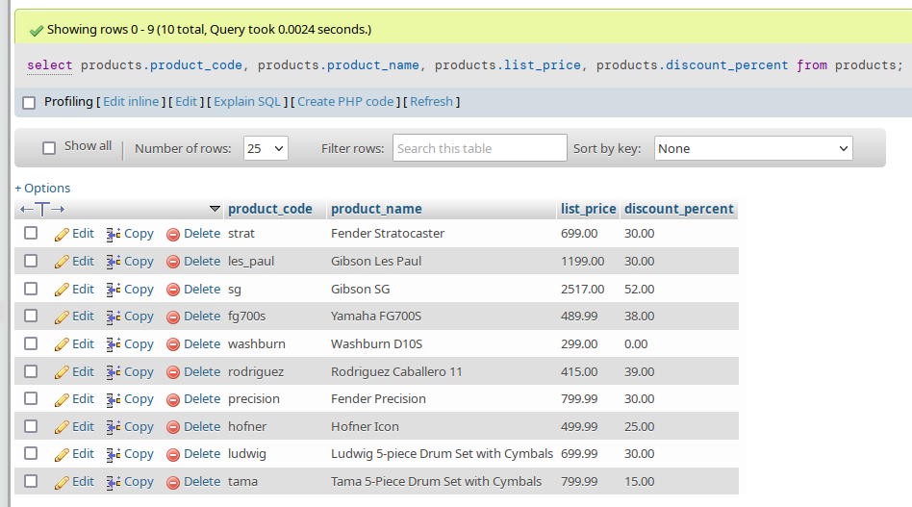
Query Solution:
select products.product_code, products.product_name, products.list_price, products.discount_percent
from products;

Problem 2:
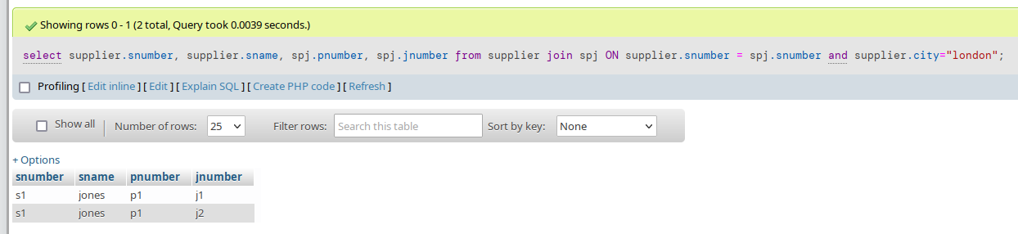
Query Solution:
select supplier.snumber, supplier.sname, spj.pnumber, spj.jnumber
from supplier join spj
ON supplier.snumber = spj.snumber and supplier.city="london";

Problem 3:
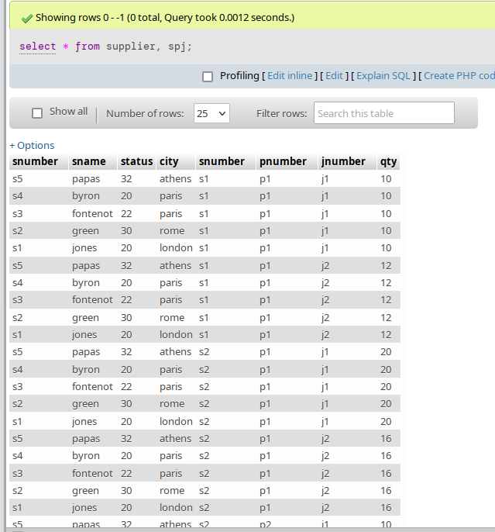
Query Solution: select * from supplier, spj;

Query 4:
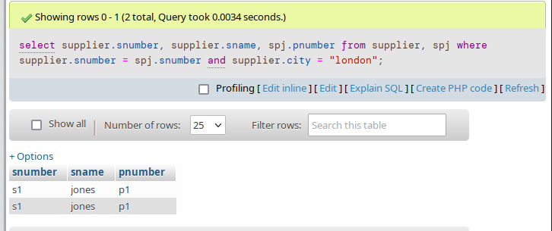
Query solution:
select supplier.snumber, supplier.sname, spj.pnumber
from supplier, spj
where supplier.snumber = spj.snumber
and supplier.city = "london";
Query 5.1:
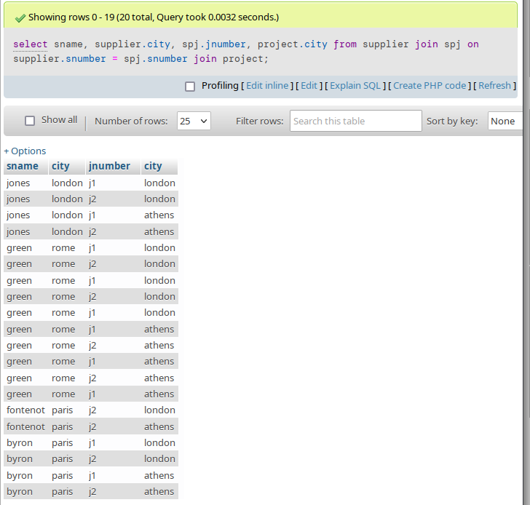
Query solution
select sname, supplier.city, spj.jnumber, project.city from supplier join spj on supplier.snumber = spj.snumber join project;
Query 5.2:
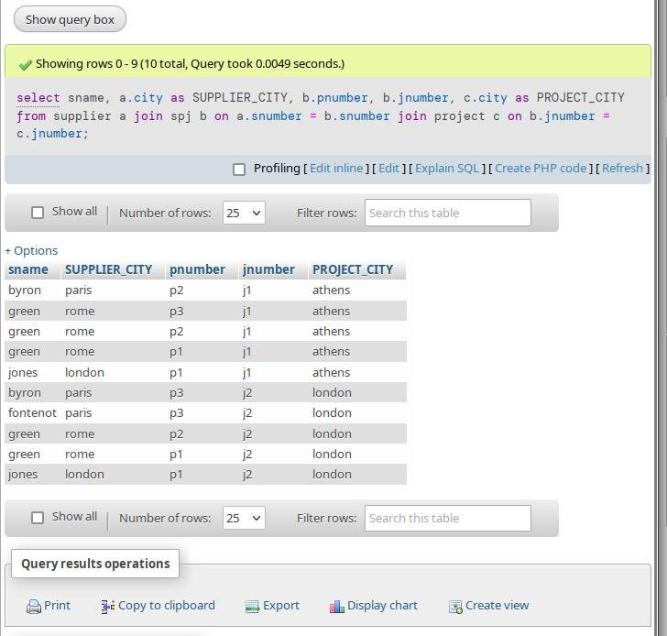
Query solution:
select sname, a.city as SUPPLIER_CITY, b.pnumber, b.jnumber, c.city as PROJECT_CITY from supplier a join spj b on a.snumber = b.snumber join project c on b.jnumber = c.jnumber;

