Caleb Fontenot
SQL Programming

1. /* select snumbers, and numbers of parts they supply and the total qty of they parts they supply */
SELECT
snumber,
COUNT(*),
SUM(qty)
FROM
spj
GROUP BY
snumber;
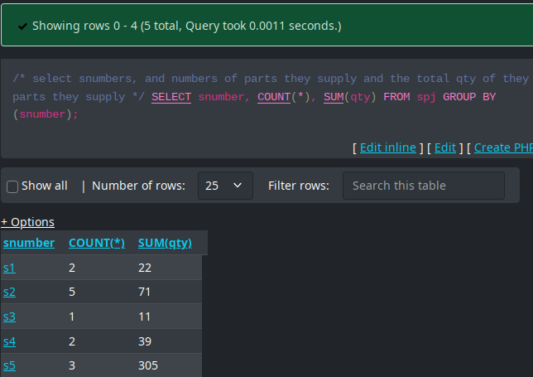

2./* find supplier number, number of parts supplied, total sum and average. 2 decimal point for the sum and for the average) */
SELECT
snumber,
ROUND(SUM(qty),
2),
ROUND(AVG(qty),
2)
FROM
spj
GROUP BY
snumber;

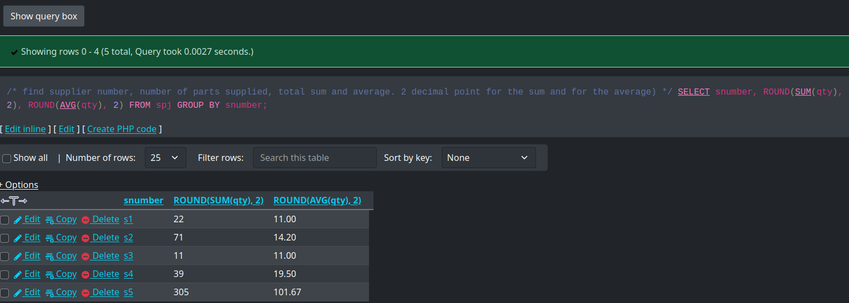
3. /* find the number of parts supplied, the minimum quantity, the maximum quantity and the average of quantity of all parts, 3 decimal places */
SELECT
pnumber,
ROUND(MIN(qty),
3),
ROUND(MAX(qty),
3),
ROUND(AVG(qty),
3)
FROM
spj
GROUP BY
pnumber;
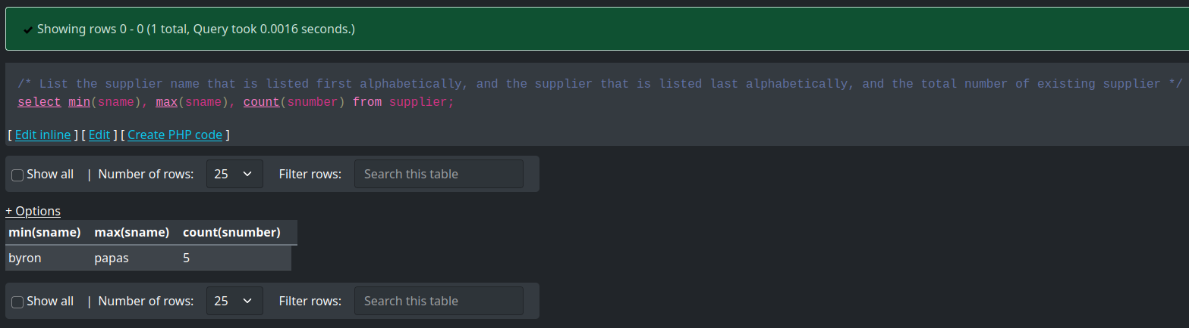
4. /* List the supplier name that is listed first alphabetically, and the supplier that is listed last alphabetically, and the total number of existing supplier */
select min(sname), max(sname), count(snumber)
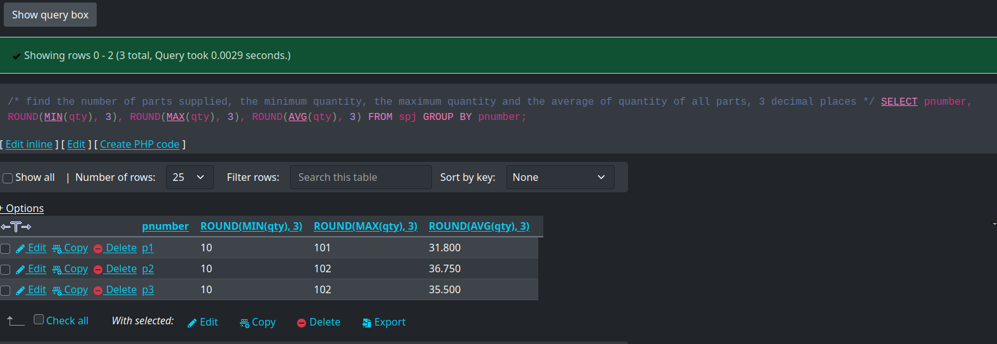
from supplier
5./*list supplier numbers and average quantity of parts supplied for those suppliers who average supplied quantity is over 50 */
SELECT
snumber,
AVG(qty)
FROM
spj
GROUP BY
snumber
HAVING
AVG(qty) > 50;
